### Semester two Examination, 2019

### Question/Answer booklet

# MATHEMATICS SPECIALIST

**UNITs 3 & 4**

## Section One:

## Calculator-free

|  |
| --- |

Your Name

Your Teacher’s Name

## Time allowed for this section

Reading time before commencing work: five minutes

Working time: fifty minutes

## Materials required/recommended for this section

***To be provided by the supervisor***

This Question/Answer booklet

Formula sheet

***To be provided by the candidate***

Standard items: pens (blue/black preferred), pencils (including coloured), sharpener, correction fluid/tape, eraser, ruler, highlighters

Special items: nil

## Important note to candidates

No other items may be taken into the examination room. It is **your** responsibility to ensure that you do not have any unauthorised material. If you have any unauthorised material with you, hand it to the supervisor **before** reading any further.

| Question | Mark | Max | Question | Mark | Max |
| --- | --- | --- | --- | --- | --- |
| 1 |  | 6 | 5 |  | 9 |
| 2 |  | 6 | 6 |  | 7 |
| 3 |  | 12 | 7 |  | 5 |
| 4 |  | 6 |  |  |  |

**Structure of this paper**

| Section | Number of questions available | Number of questions to be answered | Working time (minutes) | Marks available | Percentage of examination |
| --- | --- | --- | --- | --- | --- |
| Section One:  Calculator-free | 7 | 7 | 50 | 51 | 34 |
| Section Two:  Calculator-assumed | 13 | 13 | 100 | 100 | 66 |
|  |  |  |  | **Total** | 100 |

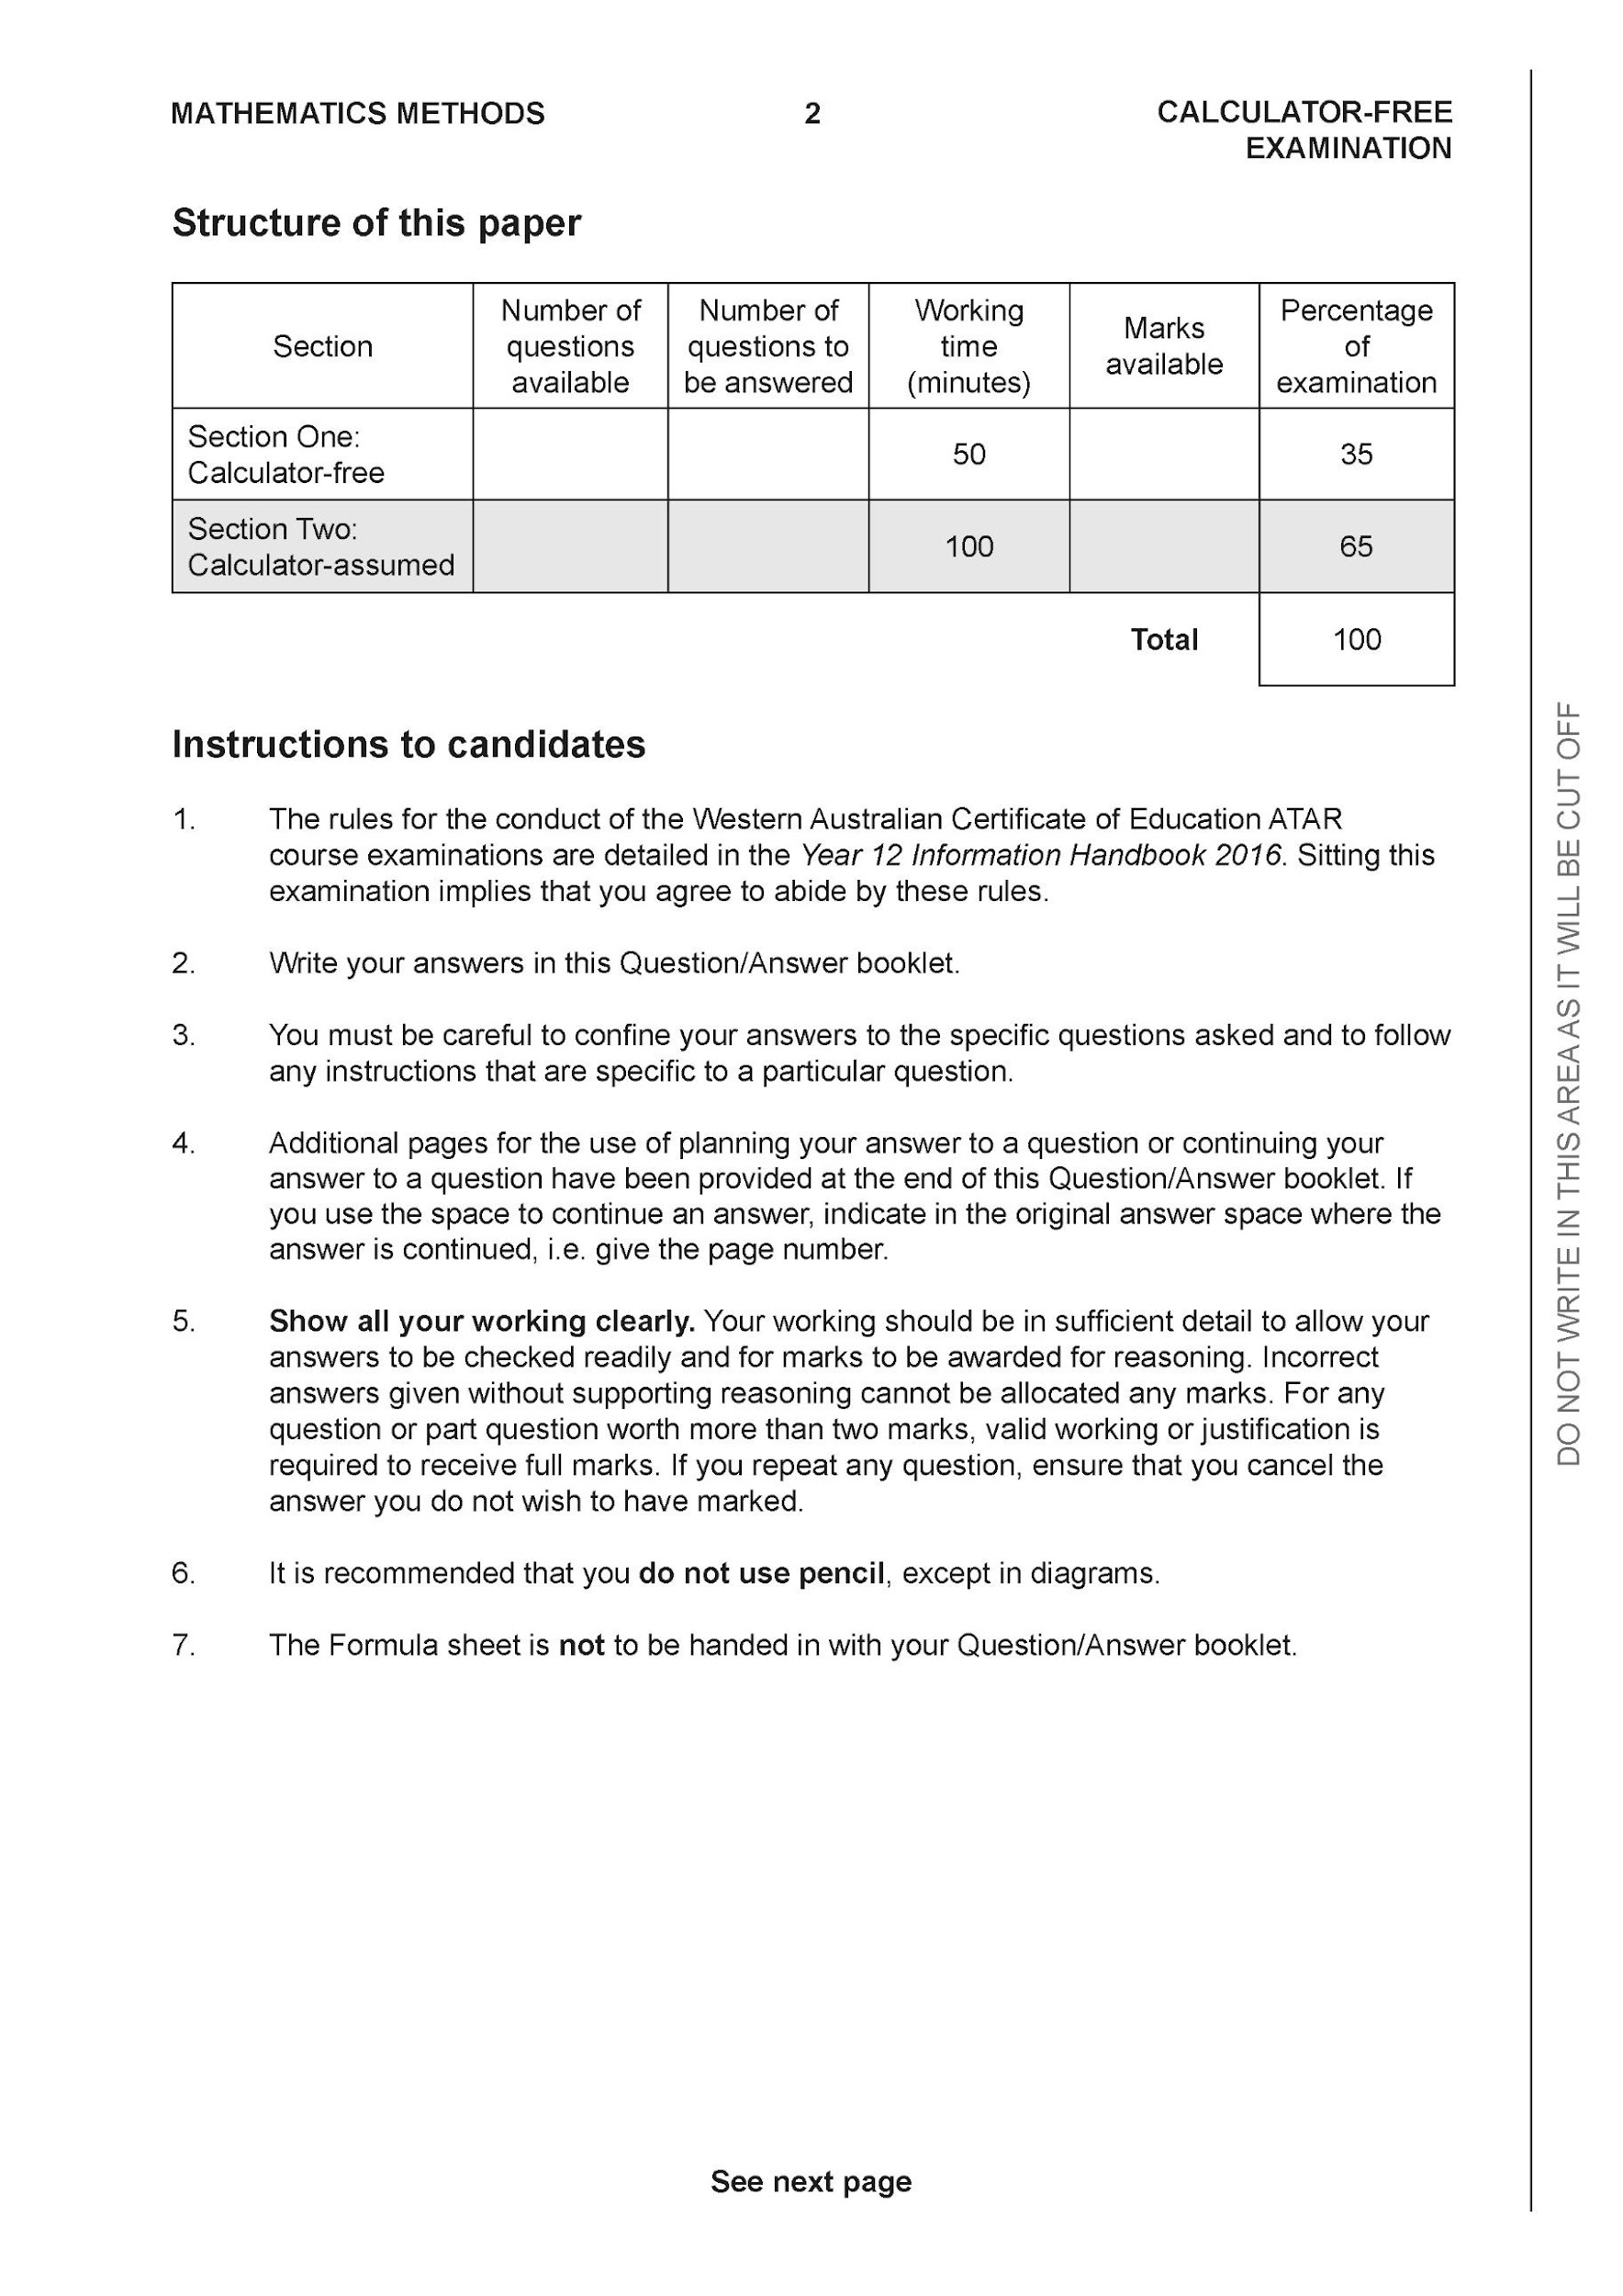

**Section One: Calculator-free (51 Marks)**

This section has **seven (7)** questions. Answer **all** questions. Write your answers in the spaces provided.

Spare pages are included at the end of this booklet. They can be used for planning your responses and/or as additional space if required to continue an answer.

● Planning: If you use the spare pages for planning, indicate this clearly at the top of the page.

● Continuing an answer: If you need to use the space to continue an answer, indicate in the original answer space where the answer is continued, i.e. give the page number. Fill in the number of the question that you are continuing to answer at the top of the page.

Working time: 50 minutes.

**Question 1 (6 marks)**

Let and .



Determine:

1. the natural domain and range of . (2 marks)



| **Solution** |
| --- |
|  |
| **Specific behaviours** |
| ✓ states domain  ✓ states range |

1. (1 mark)



| **Solution** |
| --- |
|  |
| **Specific behaviours** |
| ✓ states rule |

1. the natural domain and range of (3 marks)



| **Solution** |
| --- |
|  |
| **Specific behaviours** |
| ✓ states natural domain with exclusion  ✓ states range with exclusion with at least one correct endpoint of interval  ✓states complete range |

**Question 2 (6 marks)**

Consider the following system of linear equations.



1. Solve for . (3marks)



| **Solution** |
| --- |
|  |
| **Specific behaviours** |
| ✓ eliminates one variable  ✓ eliminates two variables  ✓solves for all variables |

1. For the following system where are constants, determine



the possible values of for i) no solutions



ii) infinite solutions. (3 marks)

| **Solution** |
| --- |
|  |
| **Specific behaviours** |
| ✓ eliminates two variables  ✓ states values for infinite  ✓states values for no soln |

**Question 3 (12 marks)**

Determine the following integrals.

1. using (3 marks)



| **Solution** |
| --- |
|  |
| **Specific behaviours** |
| ✓ changes variables  ✓ integrates correctly  ✓adds a constant and expresses in terms of x only |

1. (3 marks)



| **Solution** |
| --- |
|  |
| **Specific behaviours** |
| ✓ uses double angle formula  ✓ integrates all terms  ✓solves for multiplied constant (no need for added constant) |

1. (3 marks)



| **Solution** |
| --- |
|  |
| **Specific behaviours** |
| ✓ uses trig identity  ✓ breaks into two integrals  ✓solves for multiplied constants (no need for added constant) |

d) (3 marks)



| **Solution** |
| --- |
|  |
| **Specific behaviours** |
| ✓ uses tan function  ✓ correct angle  ✓solves for multiplied constant(no need for added constant) |

**Question 4 (6 marks)**

1. Express the following expression into partial fractions (3 marks)



| **Solution** |
| --- |
|  |
| **Specific behaviours** |
| ✓ uses three fractions  ✓ solves for one constant  ✓solves for all constants |

1. Hence evaluate (Do not simplify) (3 marks)



| **Solution** |
| --- |
|  |
| **Specific behaviours** |
| ✓ uses ln function for two fractions  ✓ integrates all terms correctly  ✓obtains un-simplified expression for definite integral |

**Question 5 (9 marks)**

Consider a plane that contains the following points, .



1. Determine a vector equation for all points in the plane above. (3 marks)

| **Solution** |
| --- |
|  |
| **Specific behaviours** |
| ✓ determines two vectors in plane  ✓ uses cross product to find normal  ✓determines vector equation of plane |

1. Determine the distance of point from the plane in part a. (3 marks)



(Do not simplify)

| **Solution** |
| --- |
|  |
| **Specific behaviours** |
| ✓ finds vector from D to point in plane  ✓ uses dot product with unit normal vector  ✓obtains un-simplified expression for distance |

1. Determine the cosine of the angle that the line makes with the plane in . (3 marks)



| **Solution** |
| --- |
|  |
| **Specific behaviours** |
| ✓ uses dot product  ✓ obtains cosine of angle between line and normal (plus or minus)  ✓obtains cosine of angle with plane |

**Question 6 (7 marks)**

Consider the logistical model defined by where are positive constants.



1. Determine the value of , ,where . Explain the significance of this value.



(2 marks)

| **Solution** |
| --- |
| Limiting value |
| **Specific behaviours** |
| ✓ states value of N  ✓ states limiting value |

1. Derive the logistical formula showing steps in your working. (5 marks)



| **Solution** |
| --- |
|  |
| **Specific behaviours** |
| ✓ uses separation of variables method  ✓ uses partial fractions and shows derivation of constants  ✓ integrates partial fractions using ln(absolute value)  ✓explains why absolute value not needed  ✓derives required solution function |

**Question 7 (5 marks)**

Evaluate the following integral showing all working.(Simplify)



| **Solution** |
| --- |
|  |
| **Specific behaviours** |
| ✓ uses cosine double angle formula at least once  ✓ expands binomial terms and uses double angle formula again  ✓ integrates terms correctly  ✓subs limits into integration and obtains un-simplified expression  ✓obtains simplified two terms(no need to factorise)  Due to complexity- follow through will only occur if solution is not made easier |

**End of section one**

**Acknowledgements**